**Results**

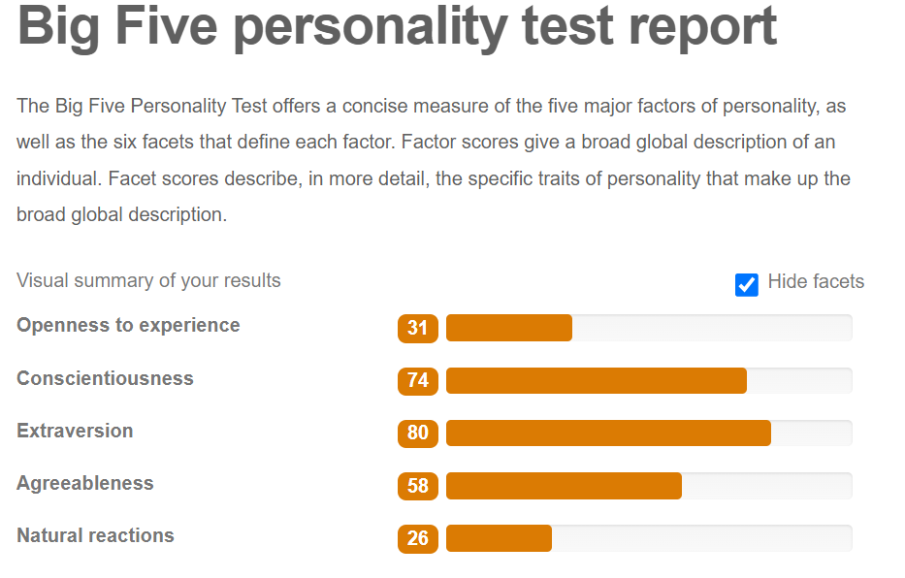

* **Openness to experience:** I like to experience new things, like a few days ago I heard *FOSSASIA Summit 2022 Cloud Skill Challenge by Microsoft* is on-going. I enrolled myself and started learning.
* **Conscientiousness:** I worked hard on my Data Structures project after exams even when most people get bored and just finish it haphazardly, I put time into it and made a good project.
* **Extraversion:** Yes, I am out going and friendly person. This week the biggest event of FAST-NUCES Procom is held, I really enjoyed in event, participated in Speed Programming Competition with my friends and also Karakoram and Bayaan rocked in concert.
* **Agreeableness:** I got accepted in both Fast Karachi and Islamabad, even though I wanted to study in Islamabad my parents wanted me to stay in Karachi as it is closer, and upon further inspection I realized that traveling to Islamabad would prove to be difficult, so based on that and my parent’s opinion I ended up picking Karachi over Islamabad.
* **Natural reactions:** It’s true I remain stressful and calm. I still remember back in 2018 when I had my first car accident, my right leg was fractured and I was completely on bed rest, I can be upset but I control my emotions and rather than wasting time I started learning online and pass examination.